ARGP Digitalization Platform
The Common Data Environment, built on your Data Template vision
Vision Alignment Brief · Prepared for Saudi Arabian Mining Company (Maaden) · July 2026
Maaden has articulated a clear vision: a common digital language for asset information, where approved standards define product types, product types define properties, and properties define Data Templates that every engineering, construction, maintenance and operations system can read. This brief shows how XD House delivers exactly that vision — and demonstrates it in a working platform you can see, click and challenge.

1. Your Vision, As You Drew It
Four principles from Maaden’s own material anchor our solution:
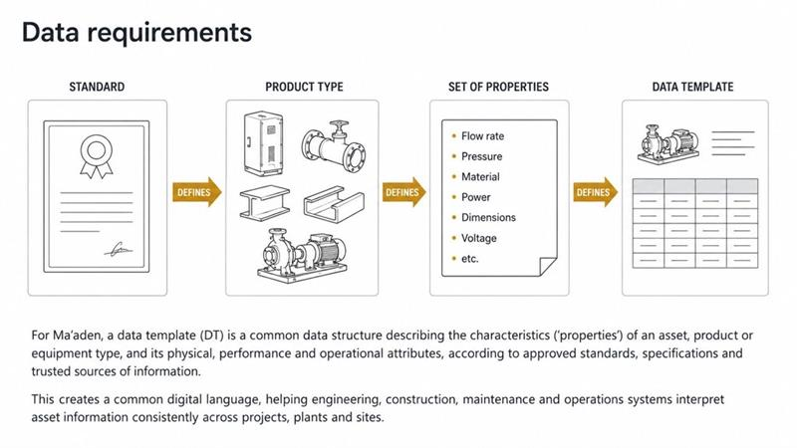
Standards define product types, properties and Data Templates — Maaden’s "common digital language".
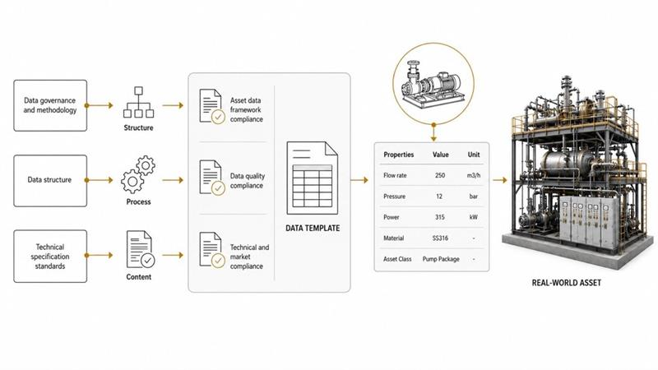
Governance, structure and technical standards validate every Data Template before it describes a real asset.

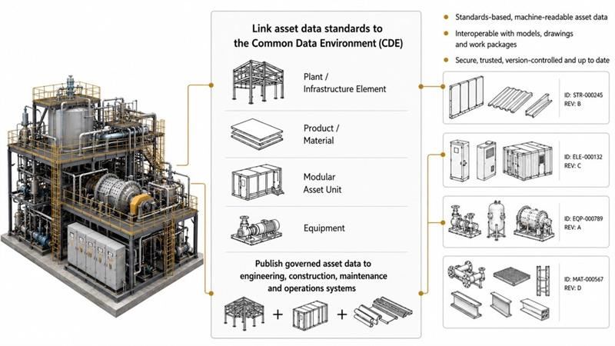
Standards-based, machine-readable asset data — identified, revision-controlled, published from the CDE.
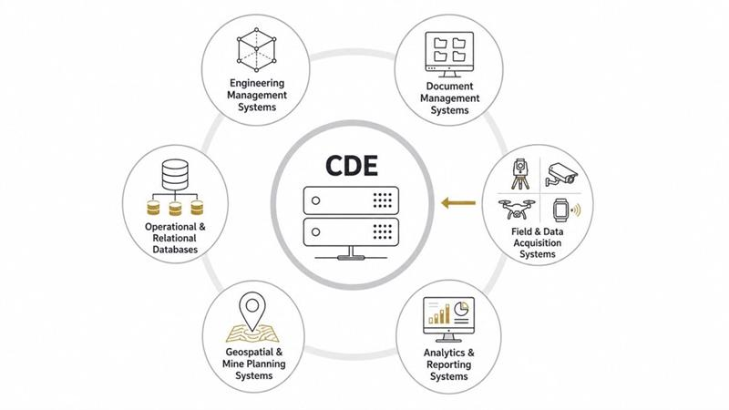
The CDE at the centre of engineering, document, field, analytics, geospatial and operational systems.

2. Our Response: the Asset Data Backbone
We implement your Data Template chain as the foundation layer of the platform’s Module M1 (Common Data Environment + Engineering Data Hub):
STANDARD ▸ PRODUCT TYPE ▸ PROPERTY SET ▸ DATA TEMPLATE ▸ TAGGED ASSET ▸ VALIDATED ▸ PUBLISHED
- Master Data Registry — every tag (STR / ELE / EQP / MAT) carried with governed IDs and revisions, mapped to the plant hierarchy Area → Unit → System → Subsystem per SoW 3.1.3.
- Data Template engine — templates derived traceably from API, ASME, ASTM, IEC and Maaden MCIS standards, with mandatory properties, units of measure and validation rules.
- Three-family compliance engine — asset data framework, data quality, and technical & market compliance checks run before any data is published, exactly as your governance diagram requires.
- Publishing hub — governed, machine-readable asset data delivered through open REST APIs to your enterprise landscape: Aconex, Primavera P6, SAP S/4HANA, AVEVA PI, MS EPM and supporting systems.
- Immutable audit and revision control — approved data is never edited in place; every change creates a new revision with a full trail, per SoW 3.1.4.

3. See It Working — Not Slides
We are building a working demonstration of this backbone, populated with examples drawn from your own vision material:
- Your pump package (250 m³/h, 12 bar, 315 kW, SS316) registered as tag EQP-000789 Rev A against template DT-EQP-PUMP-001, derived from API 610.
- Live validation: three seeded assets each fail a different compliance family — a missing mandatory property, a units mismatch, a value below the ASTM minimum — and are corrected, re-validated and approved on screen.
- One-click publishing with payload preview and cryptographic integrity hash, showing precisely what each downstream system receives.
- Dashboards for template coverage, compliance pass rates and publish activity — the engineering-maturity visibility called for in SoW 3.1.7.
- A fully bilingual Arabic–English interface: one click switches the entire platform to Arabic with right-to-left layout, while engineering identifiers and units remain in their international form — supporting Saudi user adoption and the Kingdom’s local-content objectives.
The demonstration runs on the same technology base proposed for production — TypeScript, React and PostgreSQL, deployable to in-Kingdom Microsoft Azure — so what you see is the product taking shape, not a mock-up.

4. Standards and Compliance, Built In
Requirement | How the platform satisfies it
ISO 19650 CDE workflow | Document states WIP → Shared → Published → Archived enforced on every deliverable
CFIHOS / ISO 15926-4 class library | Product-type hierarchy and property dictionary aligned to industry reference data
IEC 81346 / Maaden tag conventions | Tag formats validated at entry; registry enforces uniqueness and hierarchy placement
SoW 3.1.3 semantic data model | Area → Unit → System → Subsystem → Tag → Document implemented natively
KSA data residency (CST CCRF) | In-Kingdom hosting on Azure Riyadh; DR in-Kingdom
NCA ECC-1:2018 + PDPL | Role-based access, ADFS/Azure AD SSO, immutable audit, SIEM integration
Open APIs, no lock-in (SoW 1.4) | RESTful APIs with published OpenAPI specification; exportable data at all times

5. Fit With the Delivery Programme
The backbone is the first thing your teams touch and the last thing they depend on. Within our 40-week programme it underpins every module: the Advanced Work Packaging pilot consumes its tags and hierarchy from Week 5; quality and procurement modules bind their records to the same registry; and the full CDE — federated model viewing, intelligent P&ID and document management — completes in Phase 4 with Gate G4 sign-off. Building the registry core early de-risks every later phase, which is why we demonstrate it first.

6. Why XD House
We are a digital construction consultancy that builds, not just advises. Your platform is delivered as your intellectual property at Final Acceptance, on open technology, with your teams trained to run it. The working demonstration is our standard of proof — we would welcome the opportunity to walk your team through it and shape the pilot together.
XD House LLC FZ · anas.ayoub@xdhouse.co · Dubai · London

